**Incident Response**

**Overview**

This incident response lab introduces core investigation techniques through network traffic analysis, file extraction, system triage, and log review. Using Wireshark, CMD, PowerShell, and DeepBlueCLI, participants detect host discovery, port scans, brute-force attempts, and file downloads; extract and verify artifacts; enumerate accounts, processes, and services; and analyze Windows Event Logs for password spraying, account creation, and PowerShell-based tool usage. The exercise concludes with mapping findings to MITRE ATT&CK techniques and building an incident timeline that connects network activity with host-based evidence..

**Tools & techniques used**

* **Network forensics:** Wireshark — filters (tcp.port==80, tcp.window_size_value >= 8000), Conversations/Statistics, Follow TCP/HTTP streams, File → Export Objects → HTTP.
* **Artifact verification:** Exported ZIP/HTTP objects, md5sum to compute hashes, unzip/examine contents.
* **Host triage (Windows):** CMD (tasklist, net users, net localgroup), PowerShell (Get-LocalUser, Get-Service, Get-ScheduledTask) and DeepBlueCLI (./DeepBlue.ps1) for bulk EVTX parsing.
* **Detection keywords & IOCs:** GET / HTTP/1.1, robots.txt 404, FTP PASS attempts, password.backup, cr4ckx0r.zip, targeted usernames, source/destination IPs and ports.
* **Adversary mapping:** Identify MITRE ATT&CK techniques (e.g., Password Spraying — T1110.003 / technique code included where appropriate), map observed actions to technique IDs.

**Lab questions (Wireshark)**

1. PCAP 1 - Identify the first evidence of host discovery scanning on the network (prior to TCP). What is the IP address and what is the protocol used?

* 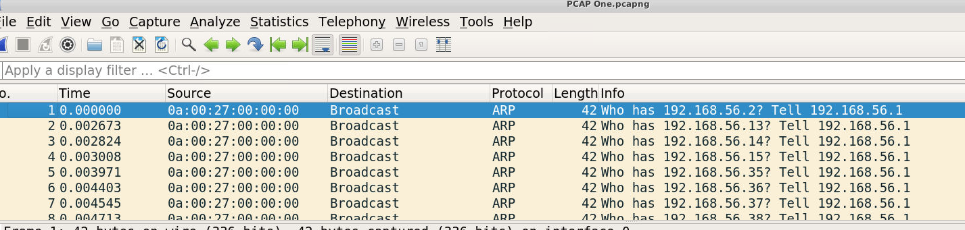Off the bat  I see there's a broadcast going out asking who is 192.168.56.2 tell 192.168.56.1. Which is saying 56.1 is the host seeing who is on the network trying to communicate

2. PCAP 1 - What IP address is being port-scanned by the malicious IP? 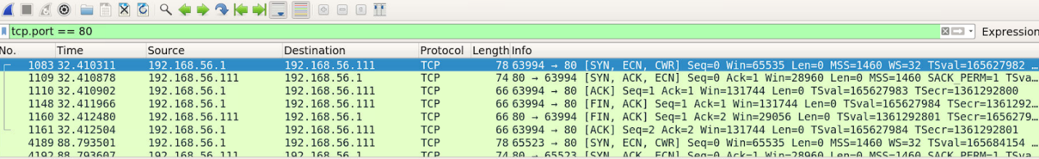

I know that port 80 is a common port scanned so if I search “tcp.port == 80” it shows what is happening with scans over port 80. And the destination on the first one is “192.168.56.111”

3. PCAP 1 - Take a closer look at some of the packets associated with FTP traffic. How many users are allowed to connect to the FTP server at once? 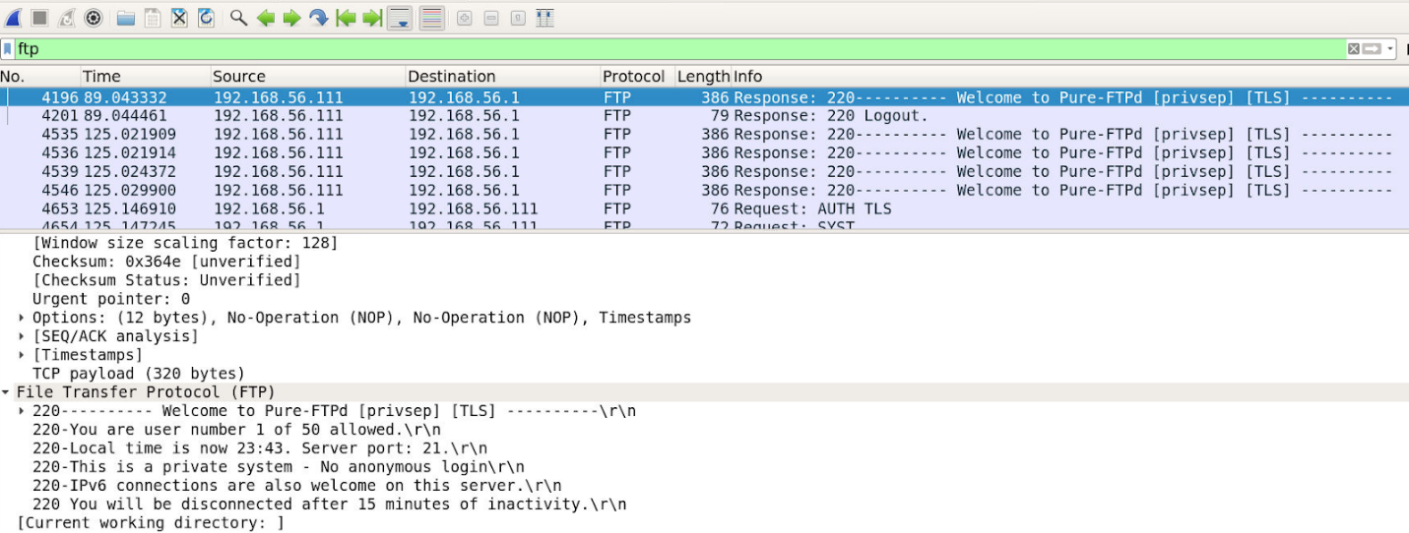

First search “ftp” (that is what the question is asking for) then proceed to details about the logs. In the FTP section “You are user number 1 of 50 allowed”

4. PCAP 1 - The attacker tries to log into the FTP server using the username "anonymous". What incorrect password is supplied? 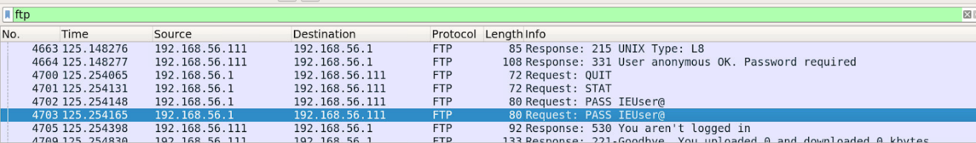

Staying in the FTP search, in the “info” field “PASS IEUser@” is stated

5. PCAP 1 - Export the robots.txt 404 page from packet 4612 as a HTTP Object and open the text file. What is the version number of Apache running on 192.168.56.111? 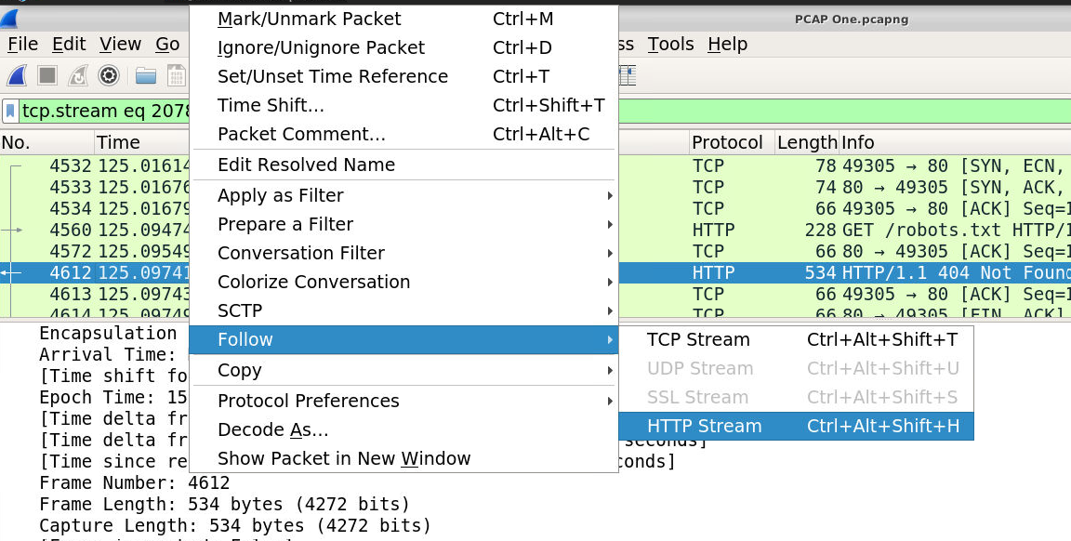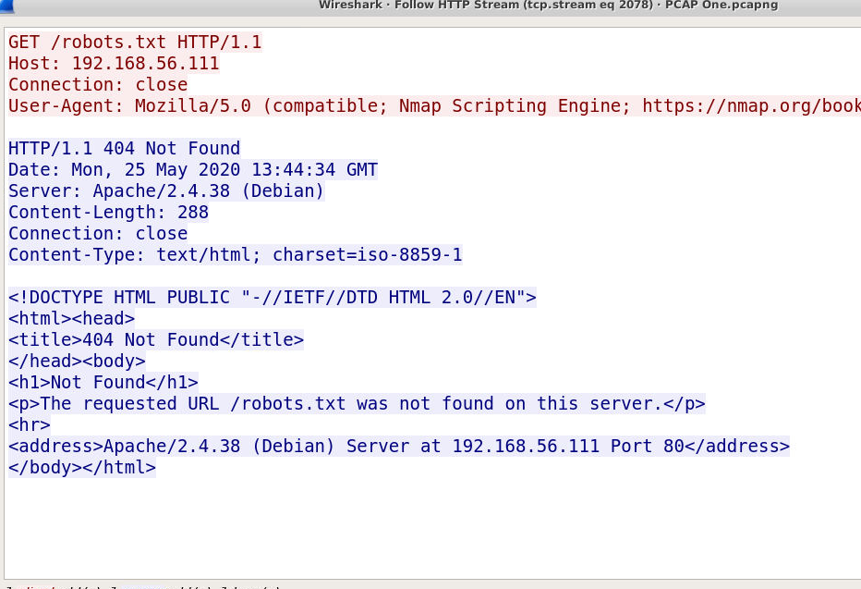

Search “http” and find No.4612 and right click and follow and go to Http Stream and the answer is located there

6.PCAP 2 - What IP address downloaded the ZIP file? 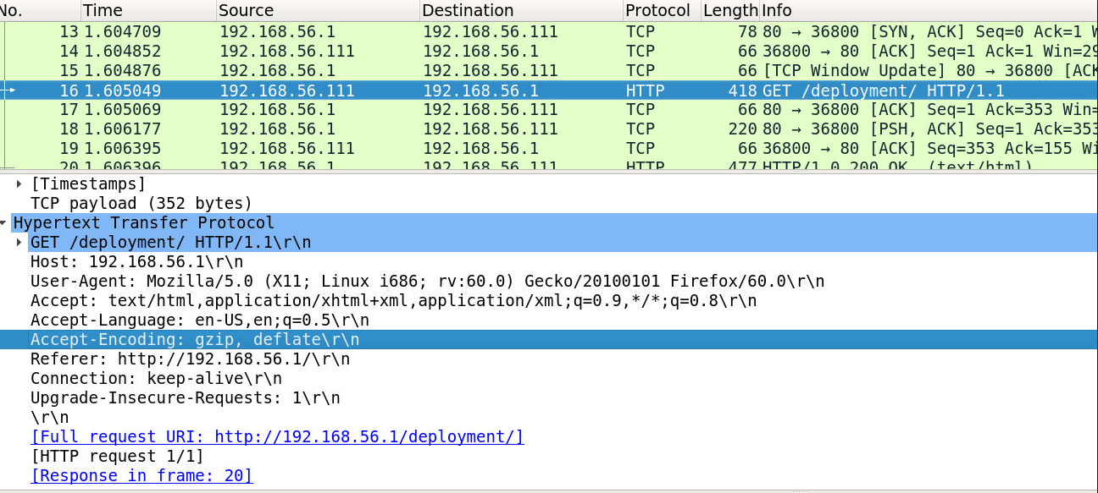

Going through the logs I found a “GET /deployment/ HTTP/1.1” in Info and going through the details there is a zip file being extracted  and the source is 192.168.56.111

7. PCAP 2 - What is the source port (server) and destination port (client) for the file download? 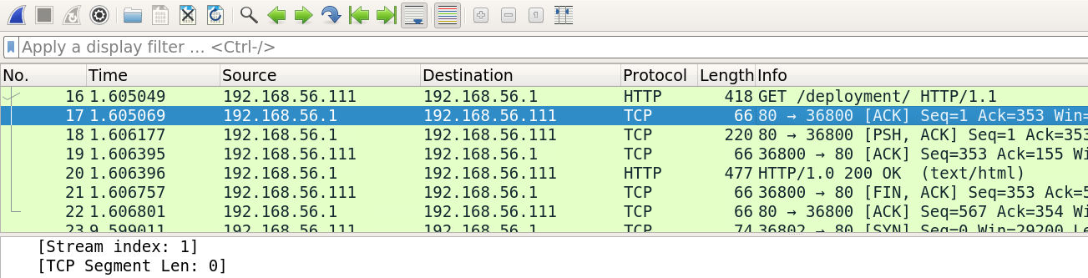

Right under that packet there’s a packet that has 80 -> 36800

8. What is the filename of the downloaded zip file? 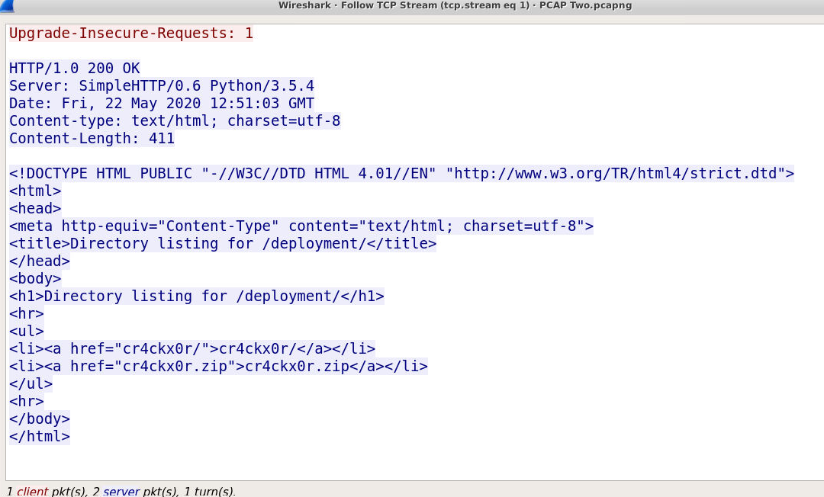

Staying in the same packet right click go to follow and go to TCP Stream and at the bottom the file is stated

9. PCAP 2 - Export the ZIP file and save it to your system. What are the first 5 characters of the MD5 hash value of the ZIP file? 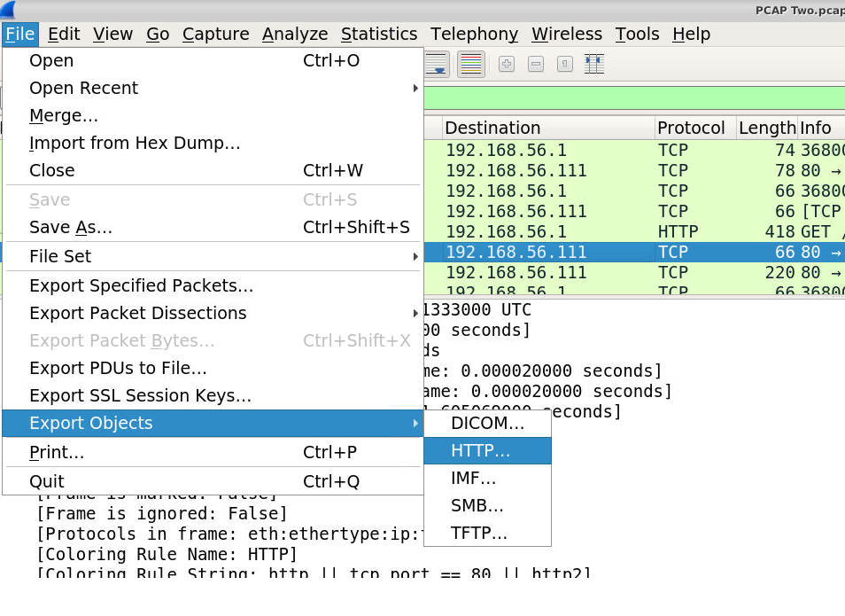

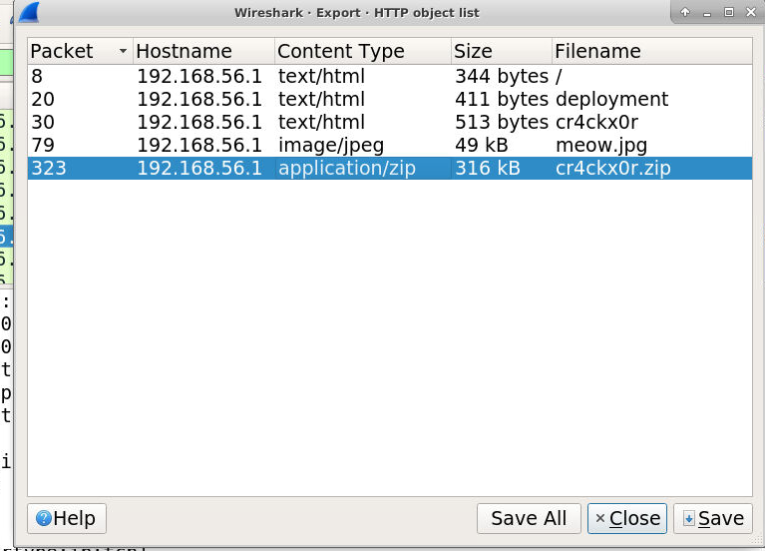

To export, go to file -> export objects -> http and select “cr4ckx0r.zip” 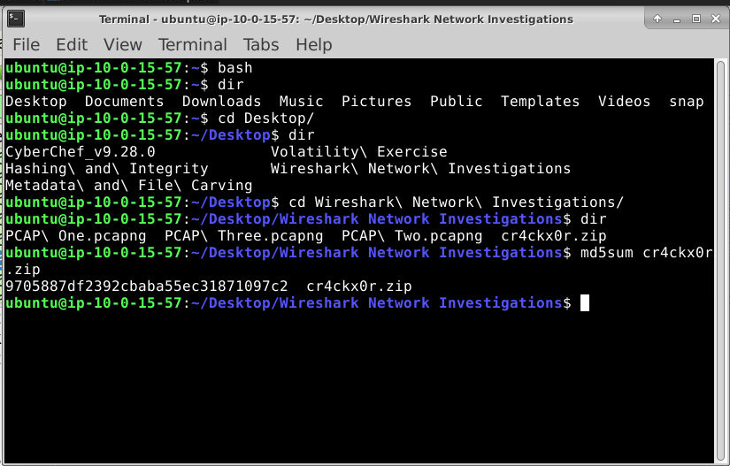

And open terminal and use “md5sum”

10. PCAP 2 - What is the name of the file inside the ZIP? (without file extension) 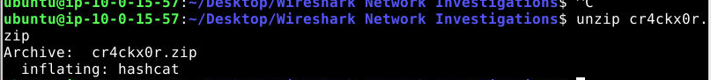

Unzip cr4ckx0r.zip

11. PCAP 2 - What are the first 5 characters of the MD5 hash value of the file inside the ZIP? 

12. PCAP 3 - What IP address is running an FTP server? 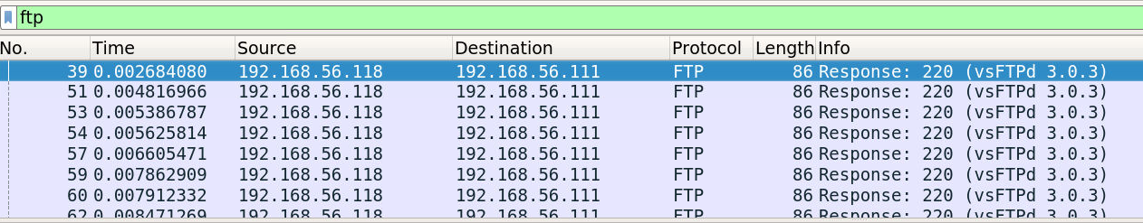

Search ftp and see in info there’s “Response:220” meaning successful authentication and the source is “192.168.56.118”

13.PCAP 3 - At what time does the attacker send the first password in a dictionary attack against the FTP server? 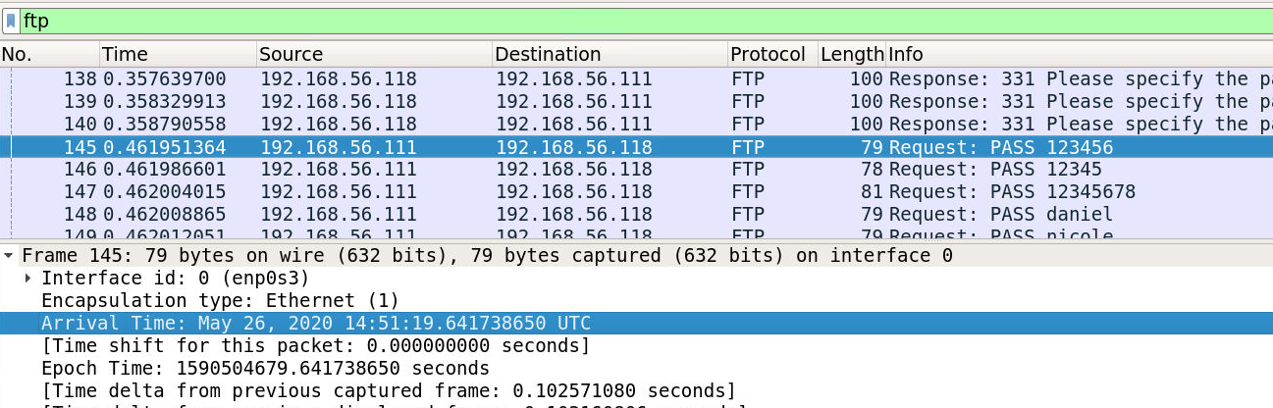

Find the first password (PASS) attempt in the log of packets and find the details arrival time

 14. PCAP 3 - At what time does the attacker successfully log into the FTP server? 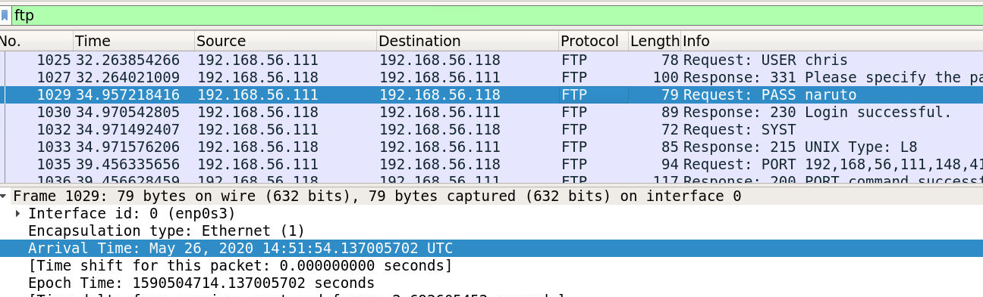

Find the packet with the successful attempt (naruto) and find the arrival time

15.PCAP 3 - What credentials allowed the attacker to log into the FTP server?

Chris Naruto (from the previous screen shot)

16. PCAP 3 - What is the name of the file downloaded from the FTP server? 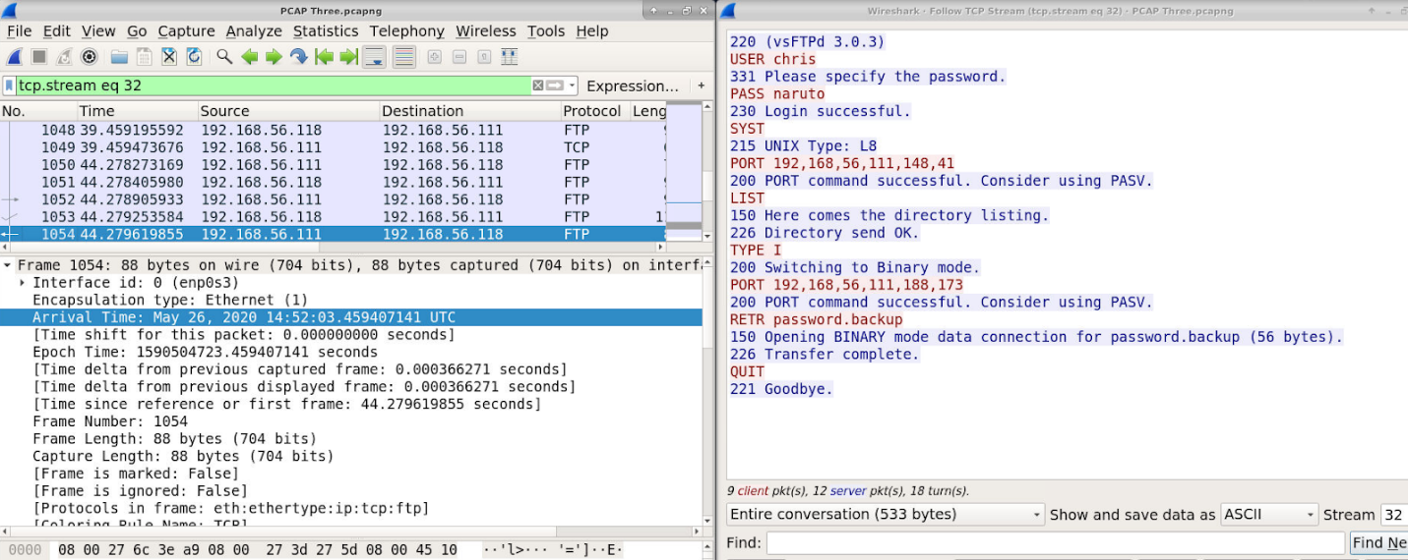

Use follow again and “password.backup” is stated (also stated in packets)

17. PCAP 3 - At what time does the attacker send the request to download this file from the FTP server? 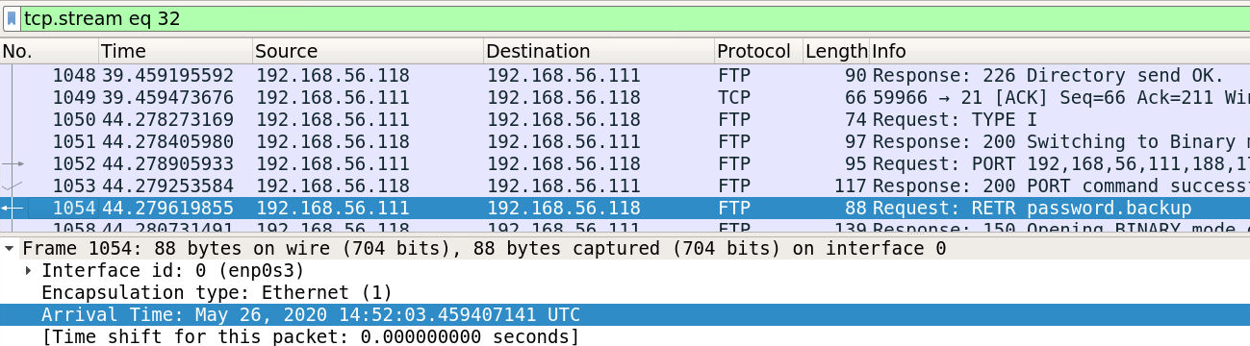

Find the packets that contains “password.backup” and look through details and find the timestamp

**Lab questions (DeepBlueCLI (PS) /CMD)**

1. Run DeepBlueCLI from a PowerShell window, and set the target evtx file as .\evtx\password-spray.evtx. How many accounts were targeted in a password spray attack, and what is the MITRE ATT&CK Technique ID for password spraying? 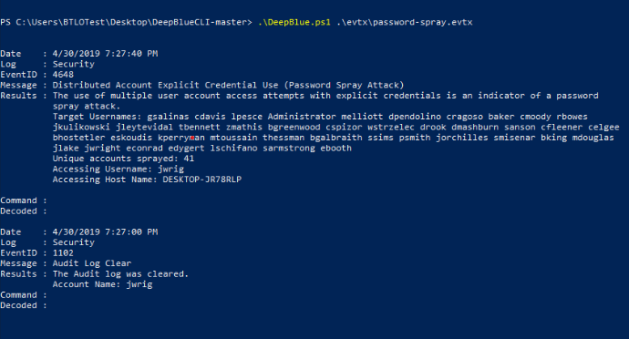

First open PowerShell and cd into where DeepBlue is located and run “.\DeepBlue.ps1 .\evtx\password-spray.evtx” and the number of accounts is stated then look up in MITRE the code for password spraying

2. Still looking at password-spray.evtx, what is the responsible user and hostname of the system?

Looking at the same output at the bottom of the “Results” the username and Hostname are stated

3. Investigate new-user-security.evtx. What is the username of the created account, and what group was it added to? 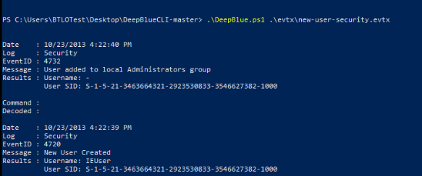

Run “.\DeepBlue.ps1 .\evtx\new-user-security.evtx”  and username and group and stated

4. Investigate powersploit-system.evtx. What is MOST RECENT the file that is being downloaded using PowerShell's 'Net.WebClient' functionality? Provide the full URL 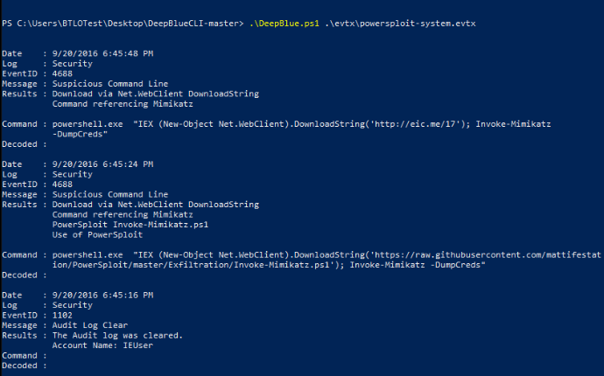

Run “.\DeepBlue.ps1 .\evtx\powersploit-system.evtx” and looking at the date field you see most recent is at the top and in the command field the URL is stated

5. To look at all of the event logs at once and export it to a text file, we can use the following argument "./DeepBlue.ps1 .\evtx\* > output.txt". Lots of open-source offensive tools are stored on GitHub, which means attackers can download them using PowerShell. Open the created text file and use CTRL+F to search for "githubusercontent". What is the .ps1 script that is downloaded? 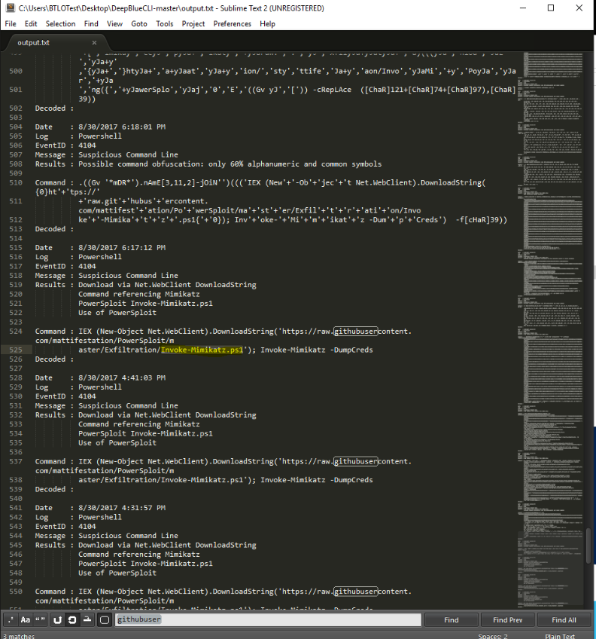

stated

6. Search for the name of the tool on MITRE ATT&CK. What is the Software ID given to this tool?

(OSINT) S0002